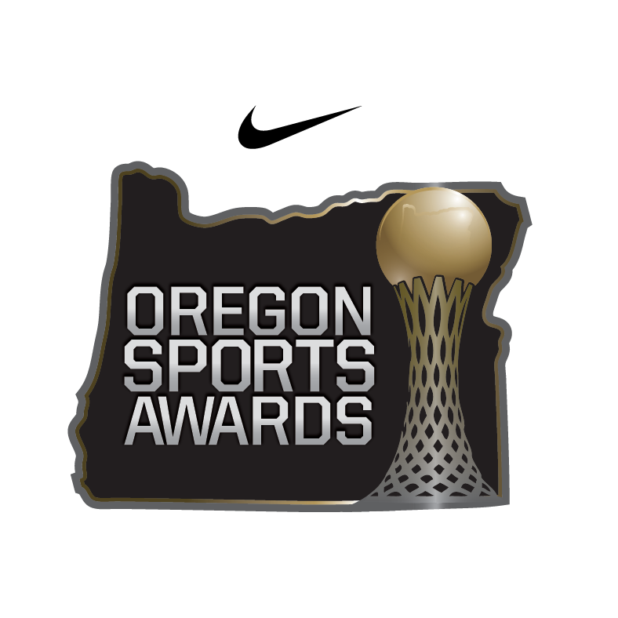
For Immediate Release

Contact:
Lauren Wilkins  ETZEL Agency  (503) 544-8905  l.wilkins@etzelgency.com | Brian Berger  BBPR  (503) 701-2215  brian@brianbergerpr.com

PREP, COLLEGIATE AND PROFESSIONAL SPORT FINALISTS ANNOUNCED FOR OREGON SPORTS AWARDS HOSTED BY NIKE
Top Oregon Pro and Amateur Athletes, Teams, Coaches and Administrators will be Revealed on Monday, June 6 during the Ceremony at the
Tiger Woods Center at Nike World Headquarters

Beaverton, Oregon – June 3, 2016 –The Nike Oregon Sports Awards has revealed the Prep, Collegiate and Pro Sports Finalists for the 2015-16 Spring Season. Through a statewide voting panel consisting of TV, radio and print personalities and respected sports professionals, finalists were nominated and selected after two rounds of voting last month. For a list of Prep Fall and Winter Finalists and a complete list of sport-specific finalists and previous winners, please reference OregonSportsAwards.com.
Winners for all categories will be announced during the 64th Annual Nike Oregon Sports Awards hosted by ESPN SportsCenter anchor and University of Oregon alum, Neil Everett, on Monday evening, June 6, at the Stanford Theater in the Tiger Woods Center at the Nike World Headquarters. A live webcast will be available at www.oregonsportsawards.com.
The evening will also recognize high school and college athletes for their dedication to athletics and giving back to the community through the Play It Forward Award, and to non-profit organizations in Oregon that are getting kids in the community active through the Play It Forward Fund, sponsored by Nike and Providence Health & Services.

Prep Spring Sports Finalists are listed below alphabetically:

Prep Baseball Player of the Year: Adley Rutschman, Sherwood (6A), Tim Tawa, West Linn (6A), Kenyon Yovan, Westview (6A)

Prep Softball Player of the Year: Lauren Burke, Marist (5A), Abby Greer, Westview (6A), Alexis Morrison, Pendleton (5A)

Prep Golfer of the Year: (Female Finalists): Camille Dozois, Lake Oswego (6A), Kiana Oshiro, Crater (5A), Ellie Slama, South Salem (6A)

Prep Golfer of the Year: (Male Finalists): Reese Fisher, South Medford (6A), Kevin Geniza, Crescent Valley (5A), Bryce Wortman, Mazama (4A)

Prep Tennis Player of the Year (Female Finalists): Lara Rakocevic, Catlin Gabel (3A), Emily Rees, Lincoln (6A), Bess Waldram, Jesuit (6A)

Prep Tennis Player of the Year: (Male Finalists): Andrew Finkleman, Grant (6A), Nathan Hampton, Churchill (5A), Dylan King, Grant (6A)

Prep Track Athlete of the Year (Female Finalists): Olivia Brooks, Summit (5A), Ella Donaghu, Grant (6A), Tieara Norman, Milwaukie (5A), Maddie Rabing, Lakeridge (6A)

Prep Track Athlete of the Year (Male Finalists): Julian Body, Jesuit (6A), Jackson Mestler, Sheldon (6A), Justin Petz, La Pine (3A)

Johnny Carpenter Prep Athlete of the Year: 6A-5A (Female): Olivia Brooks, Summit High School; Ella Donaghu, Grant High School; Evina Westbrook, South Salem High School

Johnny Carpenter Prep Athlete of the Year: 6A-5A (Male): Justin Herbert, Sheldon High School; Osawaru Odighizuwa, David Douglas High School; Tim Tawa, West Linn High School

Johnny Carpenter Prep Athlete of the Year: 4A-1A (Female): Catherine Clemens, Burns High School; Amber Lease, Mazama High School; Kayce Mock, Sutherlin High School

Johnny Carpenter Prep Athlete of the Year: 4A-1A (Male): Hassan Ibrahim, Jefferson High School; Alex Holland, Triad High School; Will Shaw, Yoncalla High School

Bill Hayward Amateur Athlete of the Year (Female): Ruth Hamblin, Oregon State University; Cheridan Hawkins, University of Oregon; Jamie Weisner, Oregon State University

Bill Hayward Amateur Athlete of the Year (Male): DeForest Buckner, University of Oregon; Ryan Crouser, University of Texas; Gary Payton II, Oregon State University

Ad Rutschman Small College Athlete of the Year (Female): Justine Benner, George Fox University; Rachel Roberts, Pacific University; McKenzie Warren, Concordia University

Ad Rutschman Small College Athlete of the Year (Male): Blake Cooper, Warner Pacific College; Alex Hoff, Linfield College; Walker Olis, Pacific University

Harry Glickman Professional Athlete of the Year (Female): Tobin Heath, Portland Thorns FC; Brianne Theisen-Eaton OTC Elite; Mariel Zagunis, USA Fencing

Harry Glickman Professional Athlete of the Year (Male): Fanendo Adi, Portland Timbers FC; Ashton Eaton OTC Elite; Damian Lillard, Portland Trail Blazers

Slats Gill Award: Caleb Porter, Portland Timbers; Scott Rueck, Oregon State University Women’s Basketball; Terry Stotts, Portland Trail Blazers

Play It Forward Award Finalists as announced in prior months:
September: Mary Beth Barnum, St. Mary’s-Medford and Parkes Kendrick, University of Portland
October: Justin Silvey, Sunset and Cheridan Hawkins, University of Oregon
November: Ben Sprouse, Central Catholic and Nathan DeVaughn, University of Portland
December: Natalie Byrne, West Linn and Ryan Nall, Oregon State University
January: Ian McClanan, Catlin Gabel and Beverly Miller, Oregon State University
February: Jean Pierre (J.P.) Mategeko, Roosevelt and Michail Pervolarakis, University of Portland
March: Gavin Begay, Madras and Deion Mock, Lewis & Clark
April: Evina Westbrook, South Salem and Katelyn Driscoll, Oregon State University
May: Erin O’Brien Powers, Jesuit and Malia Santos, Willamette University

About the Play It Forward Award
Between September 2015 to May 2016, the Play It Forward Award has recognized one high school and one college athlete each month for the great work they are doing to give back to their communities across Oregon. Committed to helping kids be physically active as an integral part of building healthier communities, Nike and Providence are partnering to recognize and award outstanding efforts to get kids moving in Oregon. Details about the Play It Forward nomination process and the nomination form can be found at www.oregonsportsawards.com/playitforward

About The Play It Forward Fund
The Play It Forward Award Fund supports non-profit organizations that are providing access to physical activity and sport opportunities for youth throughout Oregon. The goal of this fund is to increase access to sport across the state of Oregon, targeting those with the least opportunity within elementary and middle schools. Presenting sponsors Nike and Providence Health & Services donated a combined $50,000 to kick start the new Play It Forward Award Fund, allowing ten $5,000 grants, one per month, to be awarded to deserving organizations throughout the 2015-2016 school year. Grant guidelines for the Youth Sports Fund can be found at www.oregonsportsawards.com/playitforward

About the Oregon Sports Awards
Originally the Hayward Banquet of Champions, the Oregon Sports Awards began in 1948 to honor Oregon’s outstanding professional and amateur athletes, teams, coaches and administrators from many levels and a wide range of sports. Today, the Oregon Sports Awards are held in the state-of-the-art, 770-seat Stanford Theater in the Tiger Woods Center at Nike World Headquarters in Beaverton, Oregon.

For more information, visit: www.OregonSportsAwards.com
Follow the Oregon Sports Awards on Facebook and Twitter:
www.facebook.com/oregonsportsawards.
www.twitter.com/ORSportsAwards or using the handle (@ORSportsAwards)

